Exp:- 06

<!DOCTYPE html>

<html lang="en">

<head>

<meta charset="UTF-8"><meta name="viewport" content="width=device-width, initial-scale=1.0">

<title>Document</title></head>

<body>

<h1>Array Operations</h1>

<label for="s1">enter the elements of the array</label>

<input type="text" id="s1"><br><br>

<button onclick="arraydisplay()">click</button>

<p id="arrdis"></p>

<h3>Remove specific element from array</h3>

<label for="s2">The element to be removed </label>

<input type="text" id="s2"><br><br>

<button onclick="removearrayelement()">Remove</button>

<p id="remove"> </p>

<h3>Check if array contain specific value</h3>

<label for="s3">the element to be specified</label>

<input type="text" id="s3"><br><br>

<button onclick="Checkarray()">check</button>

<p id="check"></p>

<h3>Empty Array</h3>

<button onclick="Emptyarray()">empty</button>

<p id="s4"></p> <script src="script.js"></script>

</body>

</html>

**JAVASCRIPT** **CODE**:

function arraydisplay(){

var str = document.getElementById('s1').value;

var array = str.split(' ');

document.getElementById('arrdis').innerHTML="Given array is : ["+array+"]";

}

function removearrayelement(){

var str = document.getElementById('s1').value;

var array = str.split(' ');

var ele = document.getElementById('s2').value;

if(array.includes(ele)){

var index = array.indexOf(ele);

array.splice(index,1);

document.getElementById('remove').innerHTML="New array is :["+array+"]";

}else{

document.getElementById('remove').innerHTML="Given array does not contain this element!"; }}

function Checkarray(){

var str = document.getElementById('s1').value;

var array = str.split(' ');

var ele = document.getElementById('s3').value;

if(array.includes(ele)){

var index = array.indexOf(ele);

document.getElementById('check').innerHTML="Element is present at index :"+index;

}else{

document.getElementById('check').innerHTML="Given array does not contain this element!";}}

function Emptyarray(){

var str = document.getElementById('s1').value;

var array = str.split(' ');

array.length = 0;

document.getElementById('s4').innerHTML="Empty Array :["+array+"]";}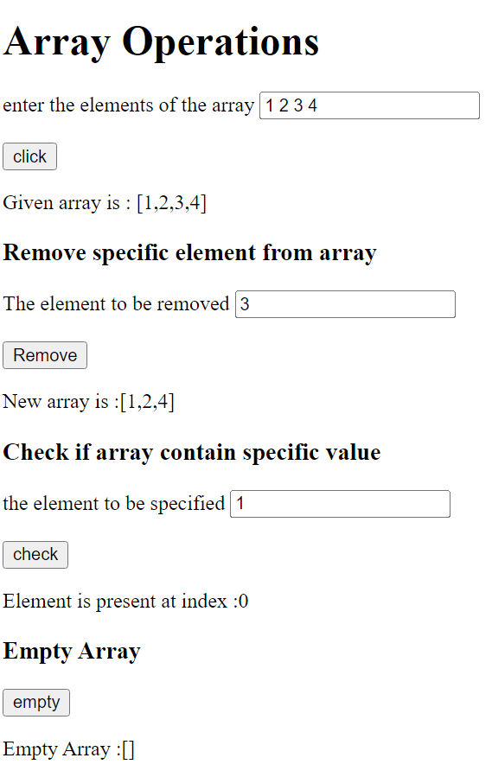

**OUTPUT**: